Name: **ZOHAIB HASSAN SOOMRO**

RollNo#: **19SW42**

Subject: **Operating System**



**Deadlock:**

**Deadlock** is very serious condition which may result into total collapse of the system. It is a situation where a set of processes is blocked because each process is holding a resource and waiting for another resource acquired by another process.

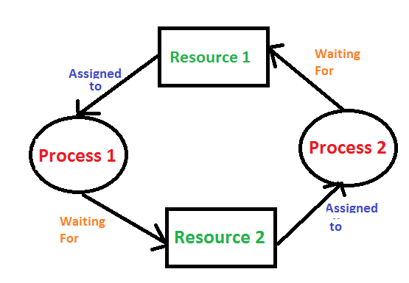

e.g Two trains are coming toward each other on the same track and there is only one track, none of the trains can move once they are in front of each other. A similar situation occurs in operating systems when there are two or more processes that hold some resources and wait for resources held by other(s).

**The cause of deadlocks**: Process(es) needing resources that another process has. This blocks from sharing resources such as memory, devices, links. Under normal operation, a resource allocation proceeds like this:

1. Request a resource (suspend until available if necessary).

2. Use the resource.

3. Release the resource.

**four conditions**

* **Mutual Exclusion**

If some resource is non-sharable which means only a single process can use it. If this is not the case then processes can’t be stopped from using a resource when require it.

E.g Full screen process in our computers can’t be used by 2 apps simultaneously.

* **Hold & wait**

If a process holds some resource and waits for some other resource. If this is not the case then the cycle of deadlock will not get completed and no deadlock will occur.

E.g A school example is a classical example of Hold & wait as school holds facilities and parents hold resources(money) and both wait for resources and facilities respectively.

* **No preemption**

A resource can’t be taken from a process unless the process releases the resource. If preemption was allowed deadlock would never occur because then no process would have been able to hold a resource for a long amount of time.

e.g if our speaker is running an audio and after sometime we click on some other audio it starts playing but incase if no preemption was allowed we would had to wait for first audio to end and if in case it was on loop we will end up in a deadlock.

* **Circular wait**

A set of processes, which are waiting for each other in circular form.

e.g if multiple processes and resources waiting for each others held resources in a circular fashion we will end up in a circular wait condition.

**Prevention**

There are three ways to handle deadlock   
1) **Deadlock prevention or avoidance:** The idea is to not let the system into a deadlock state.   
One can zoom into each category individually, Prevention is done by negating one of above mentioned necessary conditions for deadlock.   
Avoidance is kind of futuristic in nature. By using strategy of “Avoidance”, we have to make an assumption. We need to ensure that all information about resources which process will need are known to us prior to execution of the process. We use Banker’s algorithm (Which is in-turn a gift from Dijkstra) in order to avoid deadlock.

2) **Deadlock detection and recovery:** Let deadlock occur, then do pre-emption to handle it once occurred.

3) **Ignore the problem altogether:** If deadlock is very rare, then let it happen and reboot the system. This is the approach that both Windows and UNIX take.

**Techniques of encryption**

Conversion of plain text to cipher text(non-readable text) is called encryption. The purpose of encryption is to hide the data from being displayed to unauthorized parties. Encryption happens through keys and it is bidirectional which means whatever is encrypted can be decrypted back.

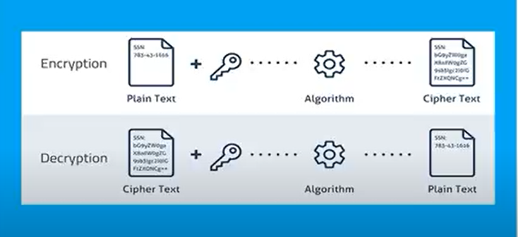

There are two types of encryption:

1. Symmetric encryption:

It is also called as **Secret key** encryption because it is a kind of encryption technique in which same key is used for encryption as well as decryption and this key is therefore called as secret key.

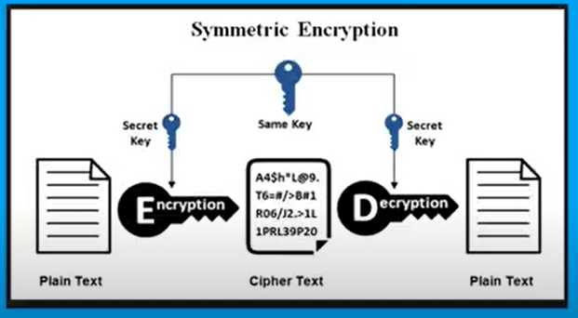

1. Asymmetric encryption:

It is a kind of encryption technique in which we have two type of keys the first one is called public key and the other is called private key. The public key is one that is used for encryption that’s why this mechanism is known as **Public key encryption** where as private key is used for decryption of encrypted data

